# 第一问

每组数据记录其线加速度和角加速度。所以表格每行有两个三维坐标数据，将每个三维数据变为一个特征数字，一行数据恰好为一个点坐标。分别对每个表格文件的每行求均值，大致加速度分布如下图：

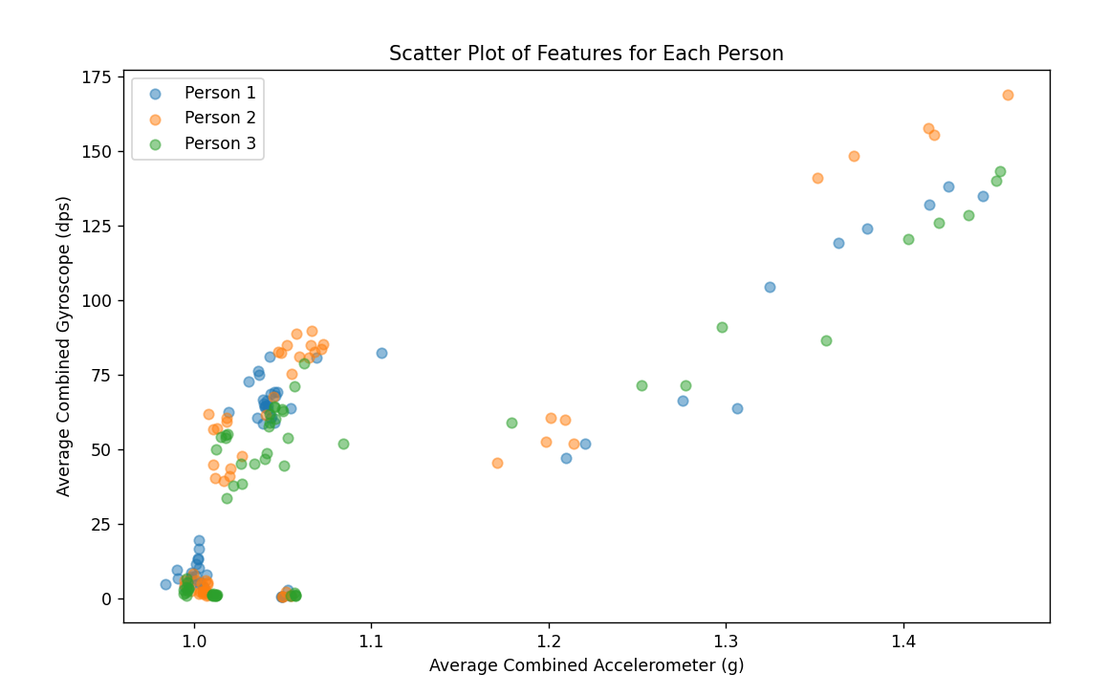

其中求相似度直接采用了余弦相似度节省计算，在寻找最优化分组时，由于代码限制，我用了贪心来简化了代码复杂度。

import os  
import matplotlib.pyplot as plt  
import pandas as pd  
import pulp  
from scipy.stats import t  
import numpy as np  
from scipy.optimize import linprog  
from sklearn.metrics.pairwise import cosine_similarity  
  
# 处理文件夹中的所有文件  
def process_folder(folder_path):  
 combined_array = [] # 初始化为 None  
  
 for filename in os.listdir(folder_path):  
 if filename.endswith('.xlsx'):  
 filepath = os.path.join(folder_path, filename)  
 data = pd.read_excel(filepath)  
  
 array1=extract_features_from_file(data) #求特征1×6的array数组  
 combined_array.append(array1)  
  
 #assert len(combined_array) == 60, "数据列表应包含60个1×6的数组"  
  
 # 将数据列表转换为60×6的二维数据矩阵  
 data_matrix = np.array(combined_array)  
  
 # 计算相似度矩阵  
 similarity_matrix = cosine_similarity(data_matrix)  
  
 #print(combined_array)  
 return similarity_matrix #最后返回的是 二维数组 60×60的 然后进行我们的相关系数计算  
  
  
  
def detect_outliers(series, alpha=0.05):  
 # 计算平均值和标准差  
 x_mean = series.mean()  
 x_std = series.std()  
 Gi = np.abs((series - x_mean) / x_std)  
  
 # 查找格拉布斯表获得临界值  
 n = len(series)  
 t_critical = t.ppf(1 - alpha / (2 * n), n - 2)  
 G_critical = ((n - 1) / np.sqrt(n)) * np.sqrt(t_critical ** 2 / (n - 2 + t_critical ** 2))  
  
 # 剔除大于临界值的异常数据  
 return series[Gi < G_critical]  
  
  
# 提取特征  
def extract_features_from_file(data):  
  
 # 异常值检测和剔除  
 data['acc_x(g)'] = detect_outliers(data['acc_x(g)'])  
 data['acc_y(g)'] = detect_outliers(data['acc_y(g)'])  
 data['acc_z(g)'] = detect_outliers(data['acc_z(g)'])  
 data['gyro_x(dps)'] = detect_outliers(data['gyro_x(dps)'])  
 data['gyro_y(dps)'] = detect_outliers(data['gyro_y(dps)'])  
 data['gyro_z(dps)'] = detect_outliers(data['gyro_z(dps)'])  
  
 acc_x = data['acc_x(g)']  
 acc_y = data['acc_y(g)']  
 acc_z = data['acc_z(g)']  
 gyro_x = data['gyro_x(dps)']  
 gyro_y = data['gyro_y(dps)']  
 gyro_z = data['gyro_z(dps)']  
  
 #取平均 变成1×6数据  
 acc_x = acc_x.mean()  
 acc_y = acc_y.mean()  
 acc_z = acc_z.mean()  
 gyro_x = gyro_x .mean()  
 gyro_y = gyro_y.mean()  
 gyro_z = gyro_z.mean()  
  
 features = np.array([acc_x,acc_y,acc_z,gyro_x,gyro_y,gyro_z])  
  
 return features #返回我们的数组  
  
  
  
def greedy_grouping(correlation_matrix):  
 n = correlation_matrix.shape[0]  
 grouped = [False] * n  
 groups = []  
  
 while not all(grouped):  
 group = []  
 # 找到第一个未分组的数据  
 for i in range(n):  
 if not grouped[i]:  
 group.append(i)  
 grouped[i] = True  
 break  
  
 # 选择另外4个数据  
 for _ in range(4):  
 max_sum = -np.inf  
 best_candidate = -1  
 for j in range(n):  
 if not grouped[j]:  
 current_sum = sum(correlation_matrix[group[k], j] for k in range(len(group)))  
 if current_sum > max_sum:  
 max_sum = current_sum  
 best_candidate = j  
  
 group.append(best_candidate)  
 grouped[best_candidate] = True  
  
 groups.append(group)  
  
 return groups  
  
  
  
  
# 主函数  
def main():  
 # 处理每个人的数据  
 acc_features1 = process_folder('Person1')  
 acc_features2 = process_folder('Person2')  
 acc_features3 = process_folder('Person3')  
 # 返回60×60数组  
 print(acc_features1)  
  
 groups1 = greedy_grouping(acc_features1)  
 groups2 = greedy_grouping(acc_features2)  
 groups3 = greedy_grouping(acc_features3)  
  
 # 将分组结果存储到Excel文件  
 df = pd.DataFrame({f"Group {i + 1}": group for i, group in enumerate(groups1)})  
 df.to_excel("group_results1.xlsx", index=False)  
 df = pd.DataFrame({f"Group {i + 1}": group for i, group in enumerate(groups2)})  
 df.to_excel("group_results2.xlsx", index=False)  
 df = pd.DataFrame({f"Group {i + 1}": group for i, group in enumerate(groups3)})  
 df.to_excel("group_results3.xlsx", index=False)  
  
if __name__ == '__main__':  
 main()

格式太难改了，表格序号为0 - 59，文件上序号为SY1 - SY60。

Person1

|  |  |  |  |  |  |  |  |  |  |  |  |
| --- | --- | --- | --- | --- | --- | --- | --- | --- | --- | --- | --- |
| **Group 1** | **Group 2** | **Group 3** | **Group 4** | **Group 5** | **Group 6** | **Group 7** | **Group 8** | **Group 9** | **Group 10** | **Group 11** | **Group 12** |
| 0 | 1 | 2 | 3 | 4 | 6 | 8 | 9 | 10 | 13 | 14 | 32 |
| 15 | 12 | 22 | 44 | 53 | 26 | 35 | 33 | 38 | 17 | 28 | 52 |
| 57 | 20 | 55 | 54 | 11 | 46 | 19 | 23 | 37 | 48 | 27 | 59 |
| 36 | 41 | 39 | 58 | 29 | 49 | 30 | 50 | 18 | 42 | 34 | 43 |
| 31 | 5 | 7 | 51 | 16 | 45 | 24 | 56 | 40 | 21 | 25 | 47 |

Person2

|  |  |  |  |  |  |  |  |  |  |  |  |
| --- | --- | --- | --- | --- | --- | --- | --- | --- | --- | --- | --- |
| **Group 1** | **Group 2** | **Group 3** | **Group 4** | **Group 5** | **Group 6** | **Group 7** | **Group 8** | **Group 9** | **Group 10** | **Group 11** | **Group 12** |
| 0 | 1 | 2 | 3 | 4 | 5 | 7 | 8 | 10 | 12 | 16 | 24 |
| 43 | 41 | 44 | 28 | 27 | 9 | 37 | 48 | 15 | 31 | 57 | 25 |
| 33 | 18 | 49 | 55 | 42 | 58 | 13 | 50 | 30 | 22 | 52 | 32 |
| 45 | 11 | 14 | 6 | 20 | 35 | 21 | 59 | 23 | 46 | 26 | 54 |
| 38 | 53 | 51 | 36 | 19 | 39 | 34 | 17 | 40 | 56 | 29 | 47 |

Person3

|  |  |  |  |  |  |  |  |  |  |  |  |
| --- | --- | --- | --- | --- | --- | --- | --- | --- | --- | --- | --- |
| **Group 1** | **Group 2** | **Group 3** | **Group 4** | **Group 5** | **Group 6** | **Group 7** | **Group 8** | **Group 9** | **Group 10** | **Group 11** | **Group 12** |
| 0 | 1 | 2 | 5 | 6 | 8 | 9 | 10 | 14 | 17 | 22 | 27 |
| 34 | 4 | 56 | 37 | 12 | 13 | 52 | 29 | 36 | 24 | 49 | 48 |
| 57 | 42 | 38 | 59 | 18 | 55 | 53 | 28 | 47 | 21 | 50 | 44 |
| 39 | 51 | 3 | 30 | 20 | 26 | 33 | 16 | 32 | 46 | 45 | 35 |
| 40 | 11 | 19 | 23 | 7 | 31 | 54 | 15 | 58 | 41 | 25 | 43 |

# 问题二

这个代码对附件二结果进行预测并存在表格文件中。

import os  
import matplotlib.pyplot as plt  
import pandas as pd  
import pulp  
from scipy.stats import t  
import numpy as np  
from scipy.optimize import linprog  
from sklearn.metrics.pairwise import cosine_similarity  
#  
#  
#  
def load_data(folder_path):  
 data = []  
 labels = []  
 persons = os.listdir(folder_path)  
 for person in persons:  
 person_path = os.path.join(folder_path, person)  
 if os.path.isdir(person_path):  
 activities = os.listdir(person_path)  
 for activity in activities:  
 activity_path = os.path.join(person_path, activity)  
 if os.path.isfile(activity_path) and activity.endswith('.xlsx'):  
 df = pd.read_excel(activity_path)  
  
 if df.shape[1] >= 6: # 需要至少6列数据  
 features = df.iloc[:, :6].values  
 data.append(features)  
 label = activity.split('t')[0]  
 label = label.split('a')[1]  
 # 提取活动类型  
 #print(label)  
 labels.append(label)  
 else:  
 print(f"Warning: File {activity_path} does not have enough columns.")  
 return data,label  
  
#  
folder_path = '附件2'  
data, labels = load_data(folder_path)  
  
print(f"Loaded {len(data)} data segments with {len(labels)} labels.")  
import pandas as pd  
from sklearn.metrics import accuracy_score  
  
  
  
file_path = 'group_results4.xlsx'  
df = pd.read_excel(file_path)  
  
# 打印数据框的前几行以检查数据  
print(df.head())  
  
  
  
# 计算每组的准确率  
accuracies = {}  
for group in df.columns:  
 pred_labels = df[group].values  
 # 确保预测标签长度与实际标签长度相匹配  
 if len(pred_labels) >= len(labels):  
 pred_labels = pred_labels[:len(labels)]  
 accuracy = accuracy_score(labels, pred_labels)  
 accuracies[group] = accuracy  
 else:  
 print(f"Warning: Length of predictions for {group} is shorter than true labels.")  
  
# 打印每组的准确率  
for group, accuracy in accuracies.items():  
 print(f"{group} Accuracy: {accuracy:.2f}")

这个代码通过随机森林，得到预测模型：

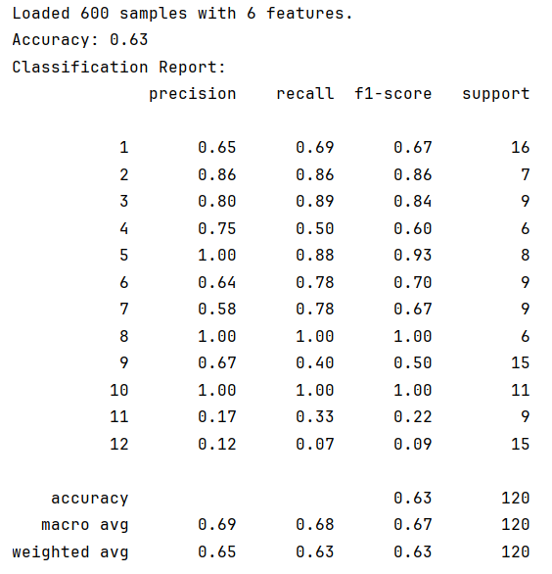

import os  
import pandas as pd  
from sklearn.ensemble import RandomForestClassifier  
from sklearn.model_selection import train_test_split  
from sklearn.metrics import accuracy_score, classification_report  
import numpy as np  
  
  
# 数据加载函数  
def load_data(folder_path):  
 data = []  
 labels = []  
 persons = os.listdir(folder_path)  
 for person in persons:  
 person_path = os.path.join(folder_path, person)  
 if os.path.isdir(person_path):  
 activities = os.listdir(person_path)  
 for activity in activities:  
 activity_path = os.path.join(person_path, activity)  
 if os.path.isfile(activity_path) and activity.endswith('.xlsx'):  
 df = pd.read_excel(activity_path)  
  
 if df.shape[1] >= 6: # 需要至少6列数据  
 features = df.iloc[:, :6].values  
 # 对每个文件提取特征的平均值作为最终特征  
 mean_features = np.mean(features, axis=0)  
 data.append(mean_features)  
  
 a=activity.split('t')[0] # 提取活动类型并转换为整数  
 a=a.split('a')[1]  
 label = int(a)  
 labels.append(label)  
 else:  
 print(f"Warning: File {activity_path} does not have enough columns.")  
 return np.array(data), np.array(labels)  
  
  
# 加载数据  
folder_path = '附件2'  
data, labels = load_data(folder_path)  
print(f"Loaded {data.shape[0]} samples with {data.shape[1]} features.")  
  
# 切分数据集  
X_train, X_test, y_train, y_test = train_test_split(data, labels, test_size=0.2, random_state=42)  
  
# 初始化和训练随机森林模型  
clf = RandomForestClassifier(n_estimators=100, random_state=42)  
clf.fit(X_train, y_train)  
  
# 进行预测  
y_pred = clf.predict(X_test)  
  
# 评估模型  
accuracy = accuracy_score(y_test, y_pred)  
report = classification_report(y_test, y_pred)  
  
print(f"Accuracy: {accuracy:.2f}")  
print("Classification Report:")  
print(report)

这个代码通过我们训练的模型将预测的附件三分类存到表格文件中

import os  
import pandas as pd  
import numpy as np  
from sklearn.ensemble import RandomForestClassifier  
from sklearn.preprocessing import StandardScaler  
from sklearn.model_selection import train_test_split  
from sklearn.metrics import classification_report  
  
  
# 数据加载函数  
def load_data(folder_path):  
 data = []  
 labels = []  
 persons = os.listdir(folder_path)  
 for person in persons:  
 person_path = os.path.join(folder_path, person)  
 if os.path.isdir(person_path):  
 activities = os.listdir(person_path)  
 for activity in activities:  
 activity_path = os.path.join(person_path, activity)  
 if os.path.isfile(activity_path) and activity.endswith('.xlsx'):  
 df = pd.read_excel(activity_path)  
  
 if df.shape[1] >= 6: # 需要至少6列数据  
 features = df.iloc[:, :6].values  
 mean_features = np.mean(features, axis=0)  
 data.append(mean_features)  
 a=activity.split('t')[0] # 提取活动类型并转换为整数  
 a=a.split('a')[1]  
 label = int(a)  
 labels.append(label)  
 else:  
 print(f"Warning: File {activity_path} does not have enough columns.")  
 return np.array(data), np.array(labels)  
  
  
# 训练随机森林模型  
def train_random_forest(X_train, y_train):  
 clf = RandomForestClassifier(n_estimators=100, random_state=42)  
 clf.fit(X_train, y_train)  
 return clf  
  
  
# 对附件三进行分类  
def classify_new_data(model, new_data_path):  
 new_data = []  
 files = os.listdir(new_data_path)  
 for file in files:  
 file_path = os.path.join(new_data_path, file)  
 if os.path.isfile(file_path) and file.endswith('.xlsx'):  
 df = pd.read_excel(file_path)  
 if df.shape[1] >= 6: # 需要至少6列数据  
 features = df.iloc[:, :6].values  
 mean_features = np.mean(features, axis=0)  
 new_data.append(mean_features)  
 else:  
 print(f"Warning: File {file_path} does not have enough columns.")  
 new_data = np.array(new_data)  
  
 # 标准化数据  
 scaler = StandardScaler()  
 new_data_scaled = scaler.fit_transform(new_data)  
  
 # 进行预测  
 predictions = model.predict(new_data_scaled)  
 return predictions  
  
  
# 加载附件二的数据用于训练  
folder_path = '附件2'  
data, labels = load_data(folder_path)  
  
# 切分数据集  
X_train, X_test, y_train, y_test = train_test_split(data, labels, test_size=0.2, random_state=42)  
  
# 训练模型  
model = train_random_forest(X_train, y_train)  
  
# 加载附件三的数据进行分类  
new_data_path = '附件3'  
predictions = classify_new_data(model, new_data_path)  
  
# 假设附件三中的文件名可以作为活动类型的标识  
activity_types = [f'SY{i + 1}' for i in range(len(predictions))]  
  
# 创建 DataFrame 以保存结果  
results_df = pd.DataFrame({  
 'Activity Type': activity_types,  
 'Predicted Status': predictions  
})  
  
# 保存结果到 Excel  
results_df.to_excel('predictions_for_attachment3.xlsx', index=False)  
  
# 打印预测报告  
print("Predictions have been saved to 'predictions_for_attachment3.xlsx'.")

# 问题三

import pandas as pd  
import numpy as np  
from scipy.stats import f_oneway  
from sklearn.ensemble import RandomForestClassifier  
from sklearn.preprocessing import LabelEncoder  
import os  
  
  
# 1. 加载实验人员数据  
def load_person_data(person_file):  
 person_df = pd.read_excel(person_file)  
 # 处理身高和体重  
 person_df['身高'] = person_df['身高'].str.replace('kg', '', regex=False).astype(float)  
 person_df['体重'] = person_df['体重'].str.replace('cm', '', regex=False).astype(float)  
 return person_df  
  
  
# 2. 加载活动数据  
def load_activity_data(activity_folder):  
 data = []  
 labels = []  
 persons = os.listdir(activity_folder)  
 for person in persons:  
 person_path = os.path.join(activity_folder, person)  
 if os.path.isdir(person_path):  
 activities = os.listdir(person_path)  
 for activity in activities:  
 activity_path = os.path.join(person_path, activity)  
 if os.path.isfile(activity_path) and activity.endswith('.xlsx'):  
 df = pd.read_excel(activity_path)  
 if df.shape[1] >= 6:  
 features = df.iloc[:, :6].values  
 mean_features = np.mean(features, axis=0)  
 data.append(mean_features)  
 a=activity.split('t')[0] # 提取活动类型并转换为整数  
 a=a.split('a')[1]  
 label = int(a)  
 labels.append(label)  
 return np.array(data), np.array(labels)  
  
  
# 3. 分析不同人员的同一活动状态是否存在差异  
def analyze_activity_differences(person_file, activity_folder):  
 person_df = load_person_data(person_file)  
 data, labels = load_activity_data(activity_folder)  
  
 activity_person_df = pd.DataFrame(data,  
 columns=['Feature1', 'Feature2', 'Feature3', 'Feature4', 'Feature5', 'Feature6'])  
 activity_person_df['Label'] = labels  
 activity_person_df = activity_person_df.merge(person_df, left_on='Label', right_on='实验人员编号')  
  
 # 根据实验人员编号分组  
 grouped = activity_person_df.groupby('实验人员编号')  
 for person_id, group in grouped:  
 print(f"Person ID: {person_id}")  
 print(group[['年龄', '身高', '体重']].describe())  
  
 # 使用 ANOVA 测试分析年龄、身高、体重的差异  
 age_groups = [group['年龄'] for person_id, group in grouped]  
 f_stat, p_val = f_oneway(*age_groups)  
 print(f"ANOVA Age Test: F-statistic = {f_stat}, p-value = {p_val}")  
  
  
# 4. 分析活动状态数据与实验人员的个人信息关系  
def analyze_correlations(person_file, activity_folder):  
 person_df = load_person_data(person_file)  
 data, labels = load_activity_data(activity_folder)  
  
 activity_person_df = pd.DataFrame(data,  
 columns=['Feature1', 'Feature2', 'Feature3', 'Feature4', 'Feature5', 'Feature6'])  
 activity_person_df['Label'] = labels  
 activity_person_df = activity_person_df.merge(person_df, left_on='Label', right_on='实验人员编号')  
  
 # 计算相关性  
 correlation = activity_person_df[  
 ['年龄', '身高', '体重', 'Feature1', 'Feature2', 'Feature3', 'Feature4', 'Feature5', 'Feature6']].corr()  
 print("Correlation Matrix:")  
 print(correlation)  
  
  
# 5. 使用随机森林模型进行人员画像  
def train_random_forest(X_train, y_train):  
 clf = RandomForestClassifier(n_estimators=100, random_state=42)  
 clf.fit(X_train, y_train)  
 return clf  
  
  
def predict_person(clf, X_test):  
 return clf.predict(X_test)  
  
  
# 6. 使用模型对文件夹中的数据进行分类  
def classify_folder_data(model, folder_path):  
 predictions = {}  
 files = os.listdir(folder_path)  
 for file_name in files:  
 if file_name.endswith('.xlsx'):  
 file_path = os.path.join(folder_path, file_name)  
 new_data = pd.read_excel(file_path)  
 X_new = new_data.values  
 pred = model.predict(X_new)  
 predictions[file_name] = pred  
 return predictions  
  
  
# 主程序  
if __name__ == "__main__":  
 person_file = '附件4.xlsx'  
 activity_folder = '附件2'  
 new_data_folder = '附件5'  
  
 # 分析人员差异  
 analyze_activity_differences(person_file, activity_folder)  
  
 # 分析活动状态与个人信息的关系  
 analyze_correlations(person_file, activity_folder)  
  
 # 准备训练数据和模型  
 X_train, y_train = load_activity_data(activity_folder)  
 clf = train_random_forest(X_train, y_train)  
  
 # 对附件 5 中的数据进行分类  
 predictions = classify_folder_data(clf, new_data_folder)  
  
 # 将结果填入表 3  
 result_df = pd.DataFrame({  
 '活动类型': list(predictions.keys()),  
 '判别结果': [list(pred)[0] for pred in predictions.values()]  
 })  
 result_df.to_excel('表3.xlsx', index=False)  
 print("Results saved to 表3.xlsx")